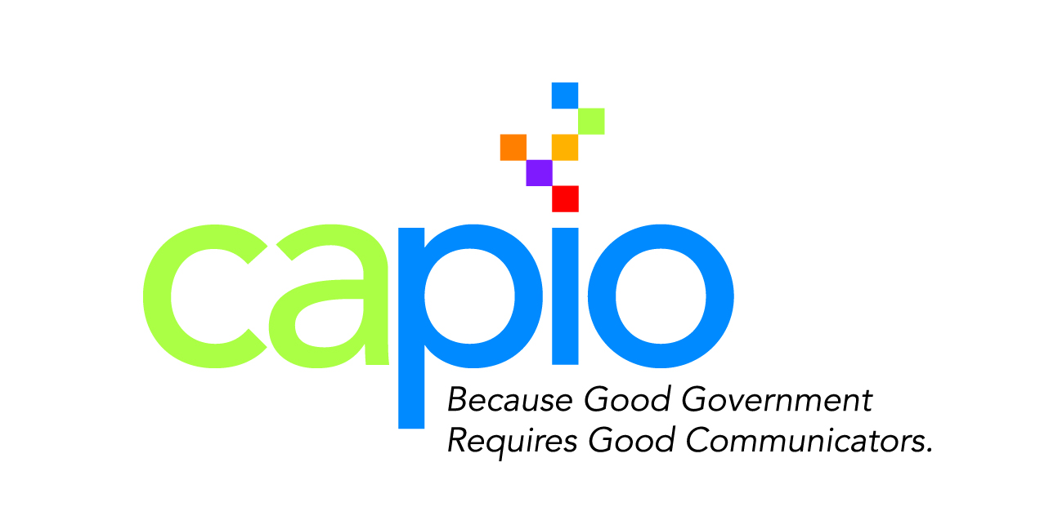
CAPIO Volunteer Form – We Need You!
Complete and email your form to info@capio.org

The CAPIO Board of Directors encourages you to learn more about your profession and enjoy the benefits of networking and working with fellow members of your industry by volunteering to assist in the organization of the following association events, programs and activities.

Simply contact a Board member below or complete your information, check activities of interest, and fax or email the form to CAPIO and they will contact you when various activities are being planned.

Print Name:
Phone: | Email:

Annual Conference – Kristeen Farlow kristeenf@cvwdwater.com (909) 987-2591
☐Publicity/Promotion – Conference promotion w/social media, e-blasts, postcards & marketing to PIO organizations.
☐Speakers – Develop session ideas and work with committee to identify and invite conference speakers.
☐Sponsorship – Reviews and updates sponsor levels and benefits and solicits sponsorship support.
☐Conference Support – Coordinates volunteers for registration area, session moderators and event support.

Excellence in Communications Awards – Krista Noonan knoonan@calstrs.com (916) 414-1400
☐Awards Promotion & Judging – Works with Chair to promote participation in Awards Program and coordinates the judges to review, score and tally awards levels.
☐Awards Dinner – Sends awards company the agency & project name and award level. Works with Chair to coordinate awards dinner ceremony, secure an MC and produce a printed program, powerpoint and script for Awards dinner.

Membership Committee – Amy Williams awilliams@cityofsacramento.org (916) 808-5014 / Kathie Martin kmartin@applevalley.org
☐Membership Retention – Welcomes new members and encourages their participation as CAPIO volunteers and attendance at events and programs. Encourages annual membership renewal.
☐Membership Recruitment – Coordinates outreach/solicitation to non-members and regional PIOs.
☐Regional Meeting Outreach – Sends Regional chairs reminders and CAPIO membership brochure and applications to encourage non-members to join CAPIO at Regional workshops and events.

Regional Workshops – Central Regional Chair Lael Wageneck lwageneck@countyofsb.org
Northern Regional Chair Leslie Arroyo leslie.arroyo@ssf.net
Southern Regional Chair Jose Arballo, Jr. jarballo@rivcocha.org
☐Regional Workshop Speaker and Topics – Works with Regional chair to develop workshop topics/focus and find speaker(s) who can successfully present the topic to regional PIOs, identify speaker deliverables and request presentations for review prior to workshop.
☐Regional Workshop Venues and Coordination – Help Regional chair find and secure workshop venues and assists chair to organize registration check-in and order refreshments if provided by workshop.

For more information on CAPIO’s committees and events contact us @

(844) CAPIO55 or info@capio.org

